 | Assignment No. 01  SEMESTER spring 2021  CS403- Database Management System | Total Marks: 20  Due Date: 05/24/2021

Objectives
The objective of this assignment is
- To be able to understand Conceptual Database Design.

Question Statement

A hostel is like a 2nd home for the students who are living outside the home. The purpose of development of hostel management system (HMS) is to manage hostel activities and to maintain all records which are difficult to manage and maintain manually. By using a computerized system, it is easy to keep the record of students, rooms, visitors, hostel staff and attendance. All this data will be stored in hostel management system database.
After getting admission in a college/university, if a student is not a local student then he/she can apply for hostel residence. At the time of registration, an admission form is filled by students. While filling a form, students need to provide visitors detail so that only registered visitors can visit a student after getting authentication by hostel admin. Admin can allocate room and hostel mess to a student. After getting admission confirmation notification from hostel authorization, a student can view available facilities and hostel allocation details. Hostel admin is responsible to provide basic facilities like library, newspaper, electricity, internet and meal facilities to all the students. In a student’s fee voucher, calculation of hostel mess charges depends on student’s presence/stay and utilization of this facility. Students can view and download hostel fee voucher, after paying fee students should upload paid fee voucher. Students can post complaints and view notification/alerts generated by hostel warden.
Hostel staff (hostel warden, employees, mess staff etc) can login to mark attendance. Hostel warden should be able to view students and staff’s attendance records, view student’s complaints and can send alerts or notifications to students. Hostel admin can view hostel records (students, staff, rooms, visitors, attendance, payment etc details). He/she can add/update hostel records (students, staff, rooms, visitors, attendance, payment etc details). Admin should also be able to generate students, staff and dues reports.
You’re required to perform the following tasks according to above scenario.

- Draw the context level diagram.
- Draw the level 0 DFD.

Solution:

context level diagram.

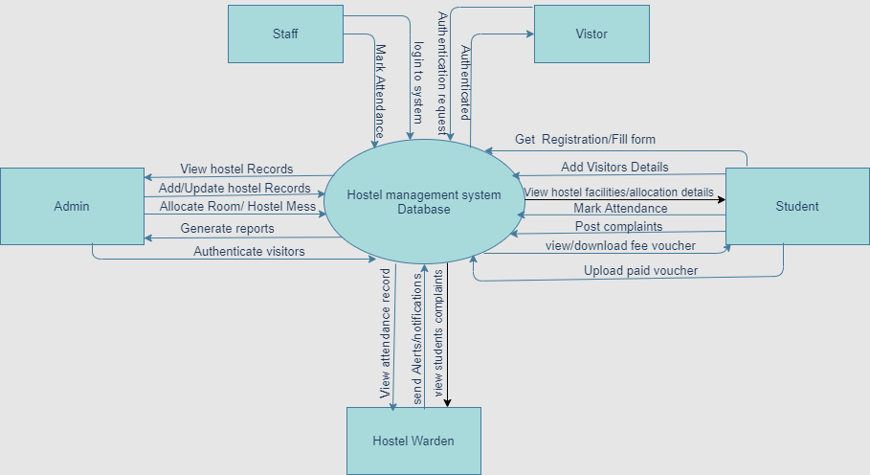

level 0 DFD.

